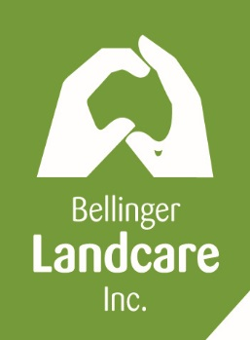
BELLINGER LANDCARE INC
ABN: 22662547254
The Old Bellingen Chambers
1a Oak Street, BELLINGEN NSW 2454
Phone: (02) 6655 0588
Phone/Fax: (02) 6655 0589
Email: belland@westnet.com.au
www.bellingerlandcare.org.au

MEMBERSHIP FORM 2016

Name of group or individual/s

_______________________________________________________________________

Address:_______________________________________________P/code____________

Phone:____________________________(h or w)____________________________(mob)

Email____________________________________

hereby applies to become a member of Bellinger Landcare Inc. I/we agree to be bound by
the rules of the organisation (www.bellingerlandcare.org.au)

All members are welcome to attend BL meetings which are held quarterly at the BL office.

Do you wish to receive BL's quarterly newsletter? (please delete)
by email by post neither
Email:
Do you wish to receive general email updates regarding Landcare activities,
upcoming workshops, etc? (please delete) Yes No

For Groups:
The following people (up to three) are nominated to represent the group:

_____________________________________ or

_____________________________________________ or

_____________________________________

_________________________________ _________________________________
*Signature & position of Office Bearer *Signature & position of Office Bearer

Date ___________________________

For individuals:

___________________________________ Date ______________________________ *Signature

*Electronically printing your name will be evidence of signature

